**INTRODUCTION TO MACHINE LEARING**

Machine Learning is used anywhere from automating mundane tasks to offering intelligent insights, industries in every sector try to benefit from it. You may already be using a device that utilizes it. For example, a wearable fitness tracker like Fitbit, or an intelligent home assistant like Google Home. But there are much more examples of ML in use.

* **Prediction:**Machine learning can also be used in the prediction systems. Considering the loan example, to compute the probability of a fault, the system will need to classify the available data in groups.
* **Image recognition**:Machine learning can be used for face detection in an image as well. There is a separate category for each person in a database of several people.
* **Speech Recognition:**It is the translation of spoken words into the text. It is used in voice searches and more. Voice user interfaces include voice dialing, call routing, and appliance control. It can also be used a simple data entry and the preparation of structured documents.
* **Medical diagnoses:**ML is trained to recognize cancerous tissues.
* **Financial industry:**andtrading:companies use ML in fraud investigations and credit checks.

## Types of Machine Learning?

Machine learning can be classified into 3 types of algorithms

1. Supervised Learning
2. Unsupervised Learning
3. Reinforcement Learning

## Overview of Supervised Learning Algorithm

In Supervised learning, an AI system is presented with data which is labeled, which means that each data tagged with the correct label.

The goal is to approximate the mapping function so well that when you have new input data (x) that you can predict the output variables (Y) for that data.

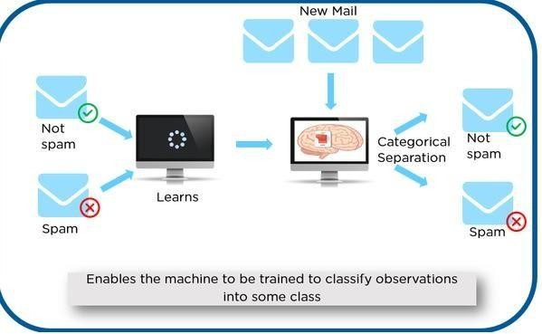

As shown in the above example, we have initially taken some data and marked them as ‘Spam’ or ‘Not Spam’. This labeled data is used by the training supervised model, this data is used to train the model.

Once it is trained we can test our model by testing it with some test new mails and checking of the model is able to predict the right output.

## Types of Supervised learning

* **Classification**: A classification problem is when the output variable is a category, such as “red” or “blue” or “disease” and “no disease”.
* **Regression**: A regression problem is when the output variable is a real value, such as “dollars” or “weight”.

## Overview of Unsupervised Learning Algorithm

In unsupervised learning, an AI system is presented with unlabeled, uncategorized data and the system’s algorithms act on the data without prior training. The output is dependent upon the coded algorithms. Subjecting a system to unsupervised learning is one way of testing AI.

## Types of Unsupervised learning:

* **Clustering**: A clustering problem is where you want to discover the inherent groupings in the data, such as grouping customers by purchasing behavior.
* **Association**: An association rule learning problem is where you want to discover rules that describe large portions of your data, such as people that buy X also tend to buy Y.

## Overview of Reinforcement Learning

A reinforcement learning algorithm, or agent, learns by interacting with its environment. The agent receives rewards by performing correctly and penalties for performing incorrectly. The agent learns without intervention from a human by maximizing its reward and minimizing its penalty. It is a type of dynamic programming that trains algorithms using a system of reward and punishment.

in the above example, we can see that the agent is given 2 options i.e. a path with water or a path with fire. A reinforcement algorithm works on reward a system i.e. if the agent uses the fire path then the rewards are subtracted and agent tries to learn that it should avoid the fire path. If it had chosen the water path or the safe path then some points would have been added to the reward points, the agent then would try to learn what path is safe and what path isn’t.

It is basically leveraging the rewards obtained; the agent improves its environment knowledge to select the next action.